**Functionalities**

**Real Estate System Usernames**

***User:***

***Username: neel***

***Password: user***

***Admin:***

***Username: neeladmin***

***Password: admin***

We have created project named **Shah13yRealEstate**. We have named our app as eproperty which you can find in our project folder. eproperty application includes several models, such as; User, Property, Advertisement, PropertyImages, etc. The eproperty application includes several models, such as; Users, Password, RoleCode, PermissionType, RolePermission, RolePermissionDetail, UserRole, Country, Province, City, PropertyCategory, Property_Sector, Property_Facing, Property, PropertyImages and Advertisement

We have created views and template for the app. All the template are in following Folder: - Templates

1)Templates/ Sidebar_base.html

2)Templates/ tempelate_base.html

These templates contains header, footer and sidebar and dynamically loads the content body part. Moreover, there are several other html pages in the eproperty folder.

We have CRUD operation performed for all the models, In each listing pages we have added functionality of sorting each columns in ascending or descending order as per user requirement. Also, we have added a search box where user can enter parameters and it could search the value in whole listing page. You can see that in the screenshot below.

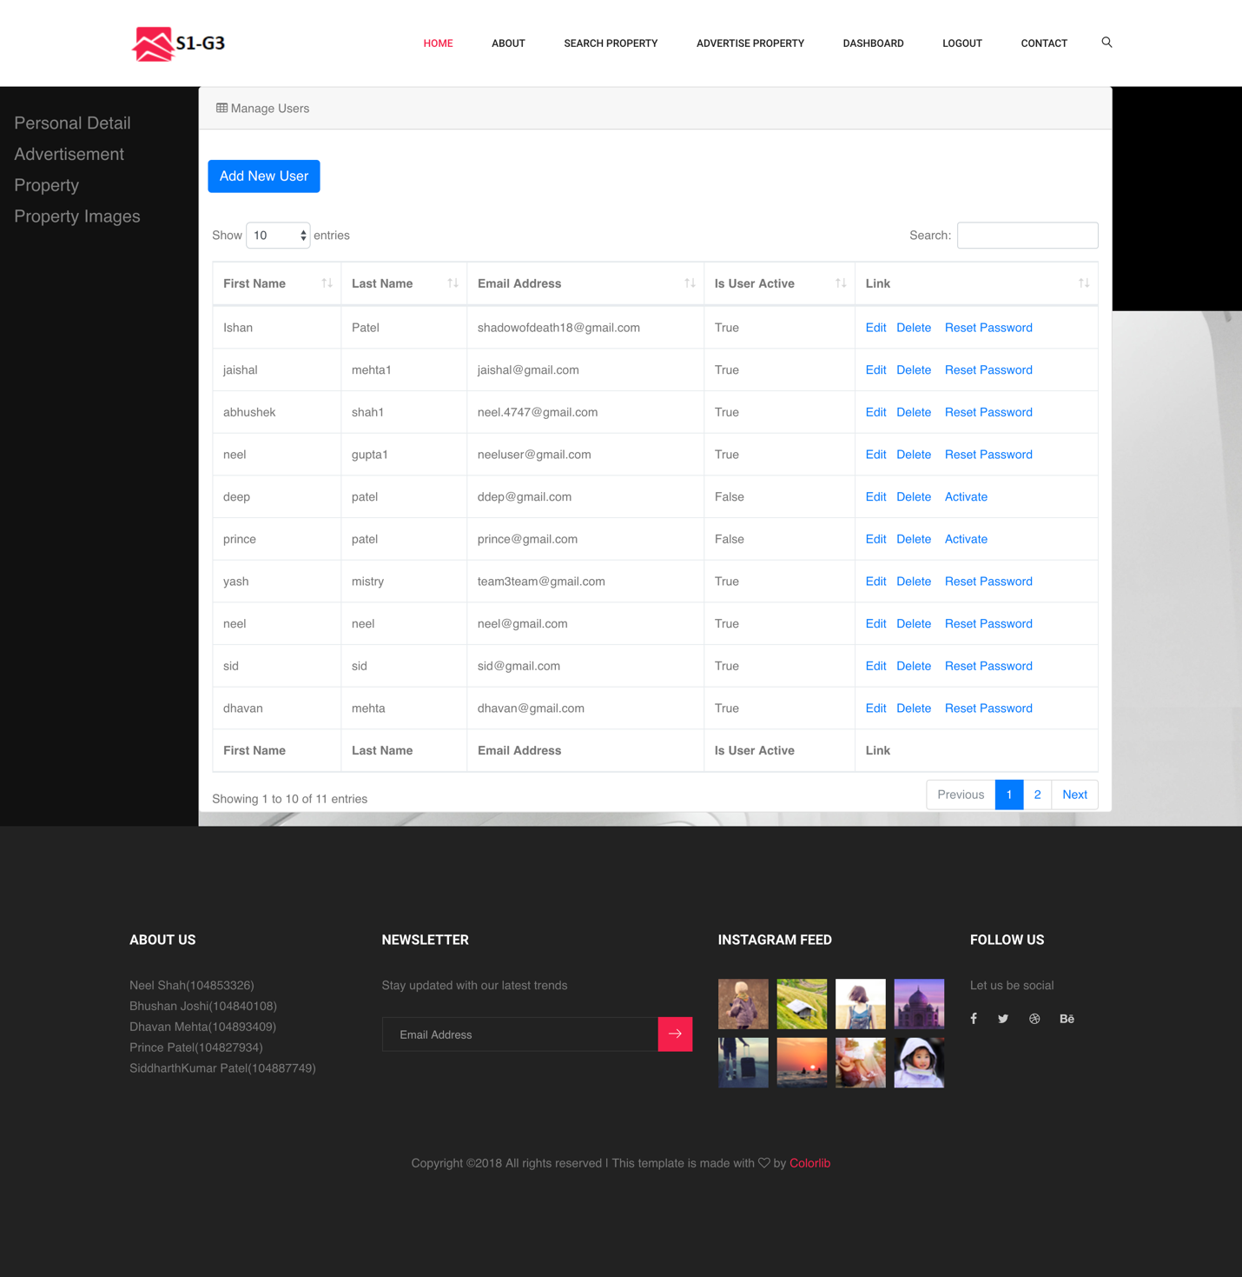

We have created a search property page where we have provided advanced search where user can search a property based on custom parameters such as

* Category: here user can select a category such as Single House, Attached House etc.
* Sector: here user can select a category such as Private, residential, government etc.
* Country: User can select country
* Province: User can select a province based on Country
* City: User can select a province based on Country and Province.

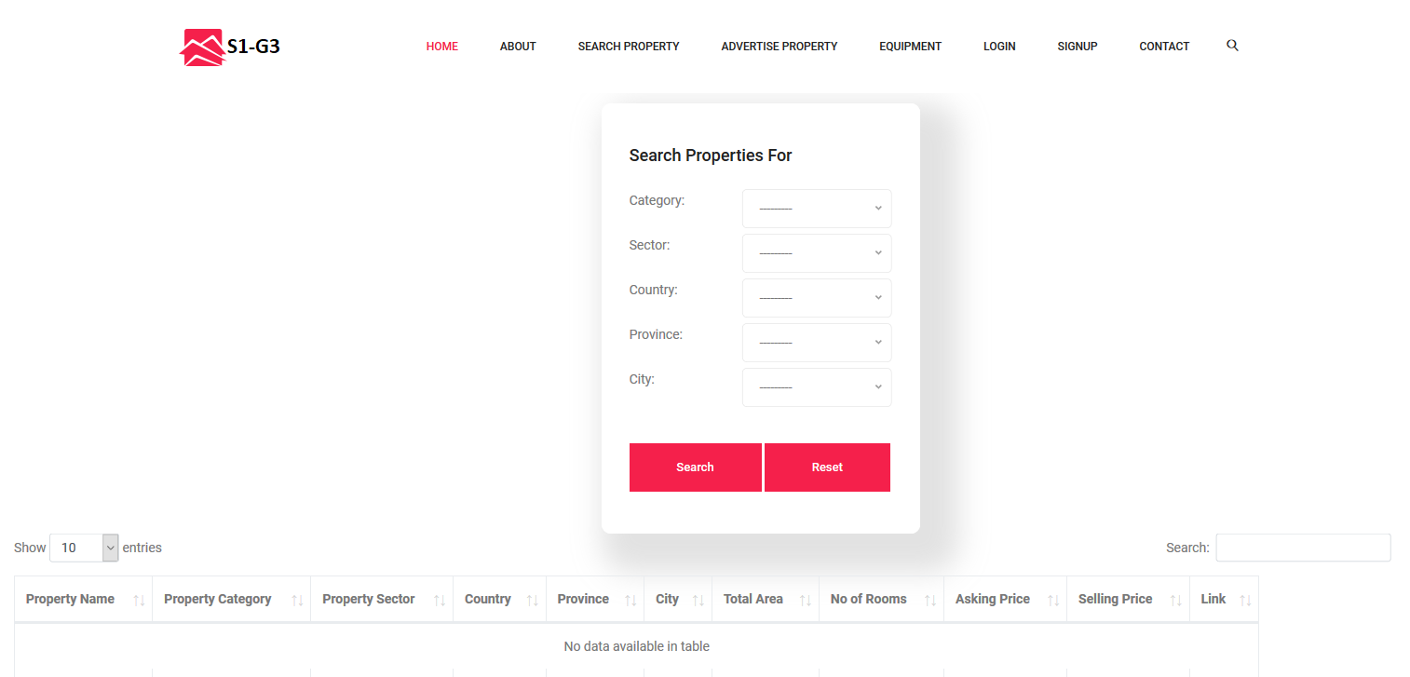

-In our Search Property page, you can see list of all properties in a table format based on the search criteria.

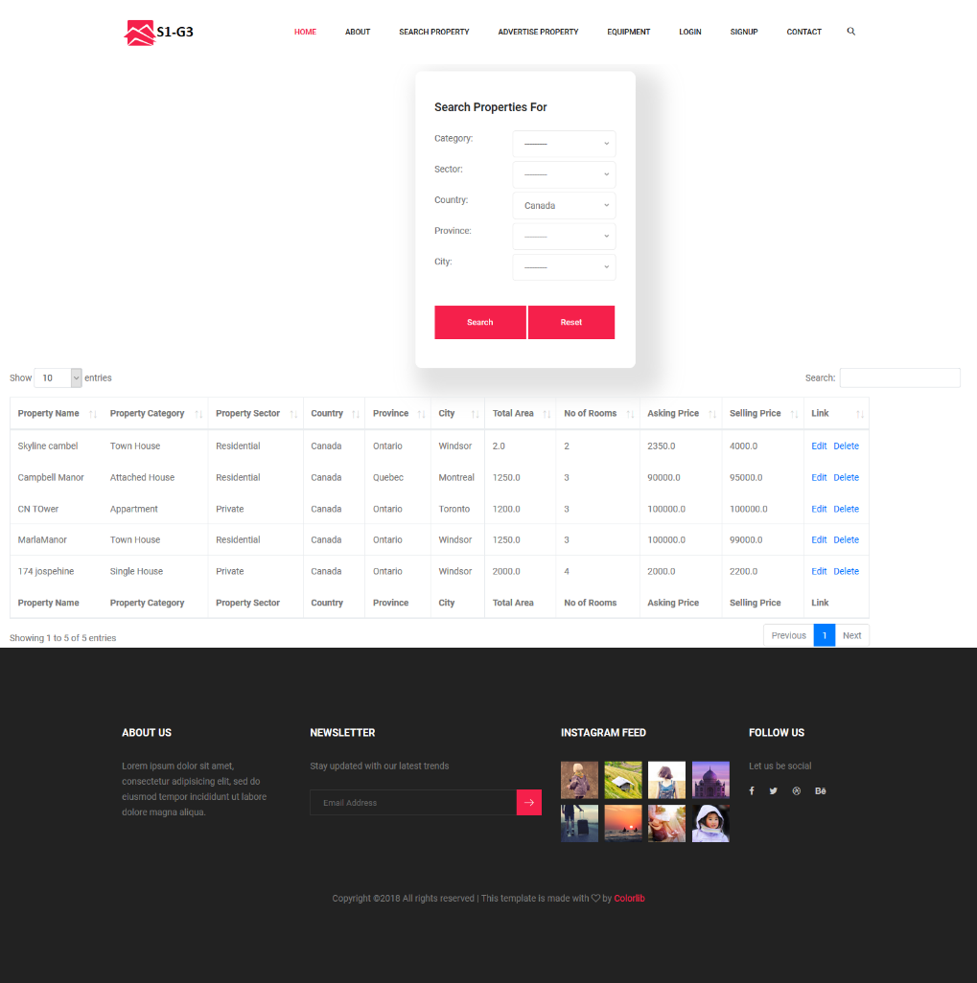

* User can click at any of the found properties to display that property’s more information in another screen.

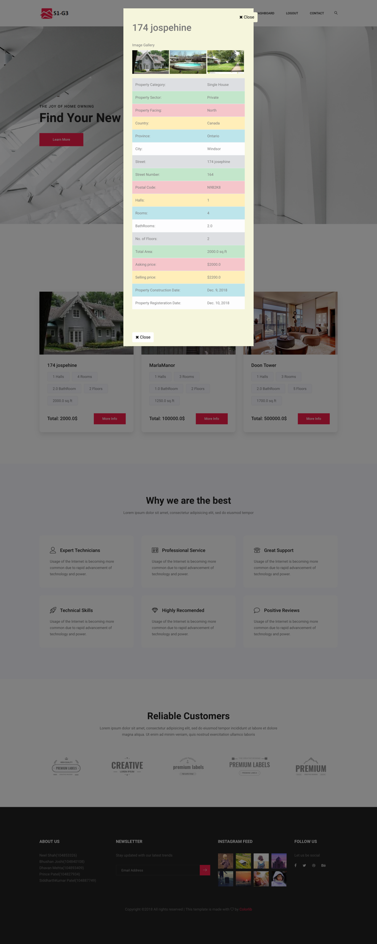

**Now we will explain how the sign in process and how the role of admin and the user affects the system.**

This is the settings.py where as you can see in the screenshot you have to provide hostname and the password for the website admin. Here you will receive all the emails regarding which users are trying to Signup.

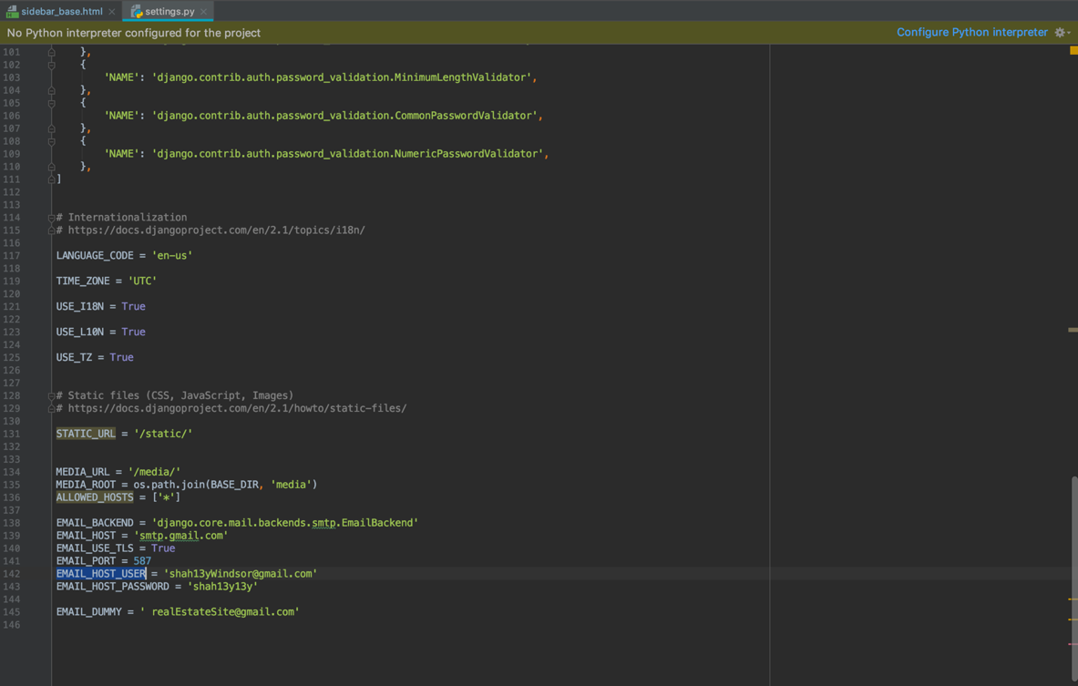

Here is the zoomed image:



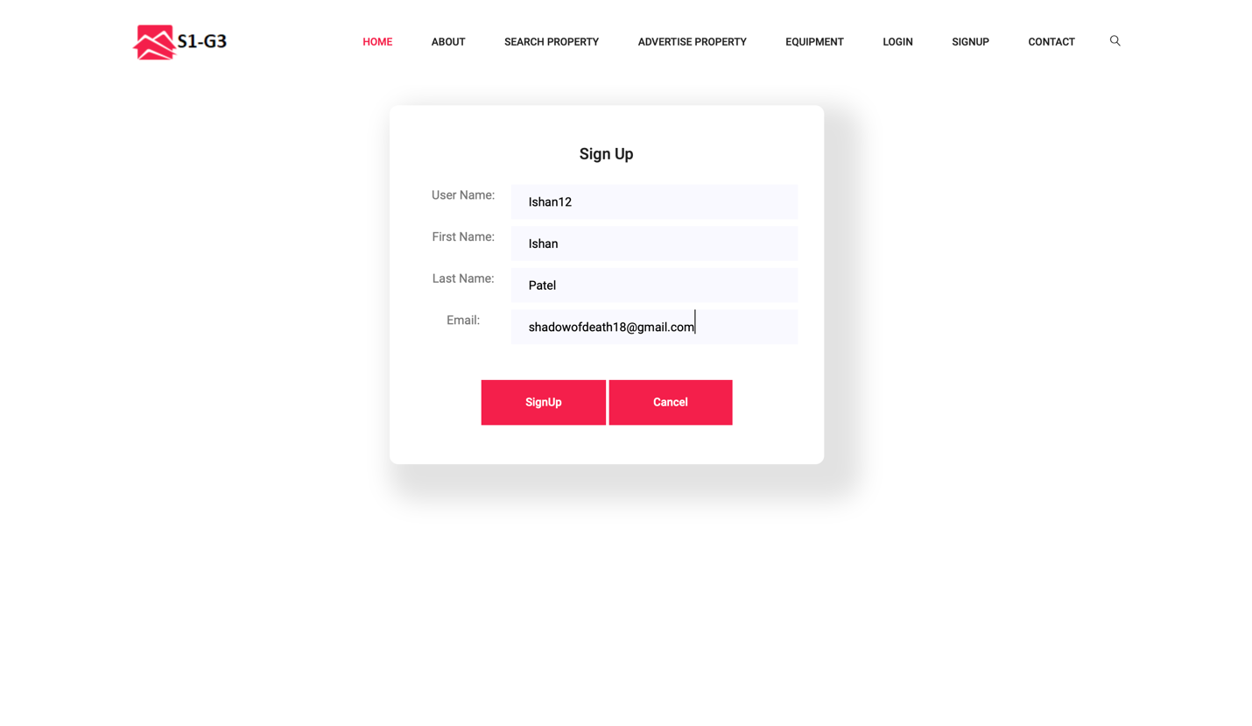

Once a user Signs up on the website this the what they will see initially. Here as a sample we have created a username as Ishan12.

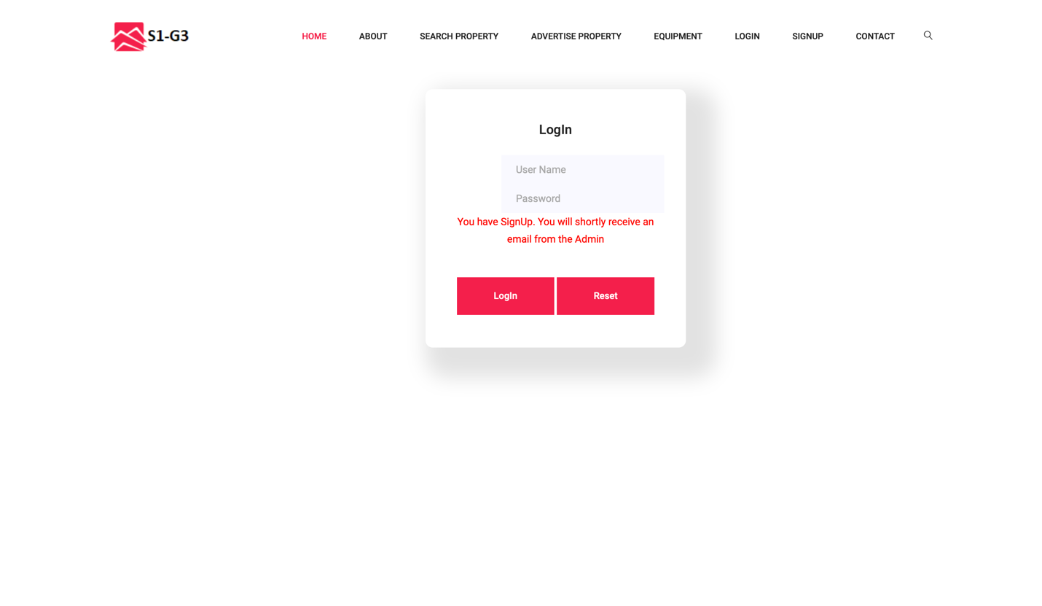

Once the user signed up on the website they will see something like this and an email would to be sent to the Administrator stating that the username with Ishan12 has signed up on the page.

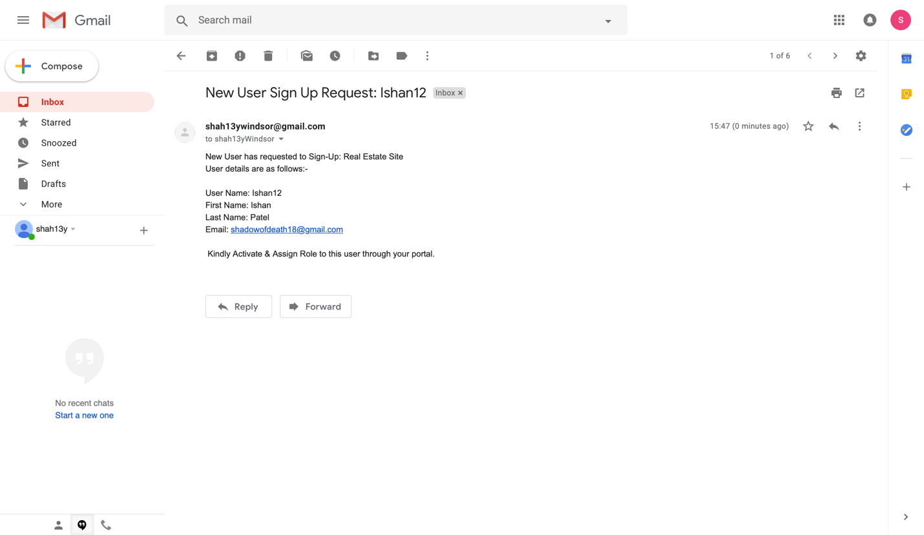

This is what the administrator will see on their email account. As you can see the system has generated a message/email saying all the information of the user. Next step would be for admin. Whether the admin wants to activate the user or not. For that the admin has to log in to their account and see all the users in system.

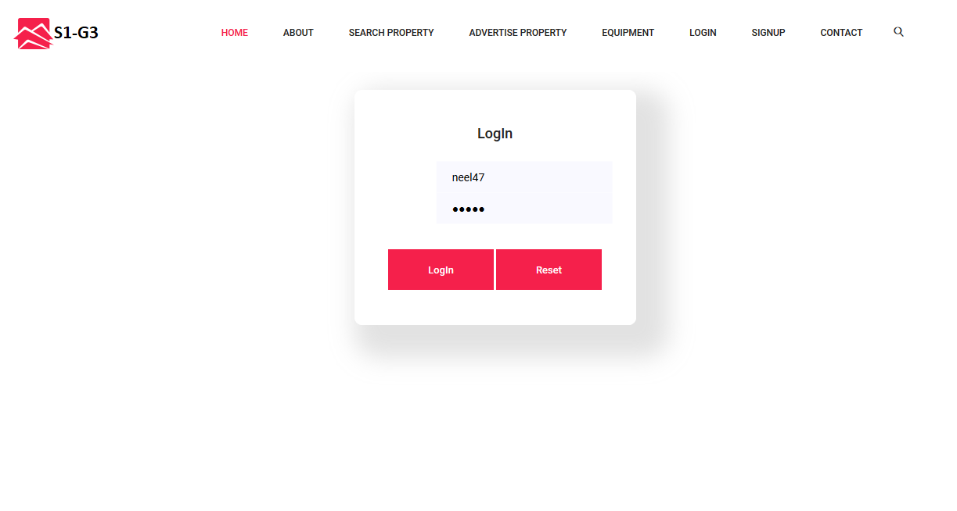

As you can see this is what the admin login page would look like.

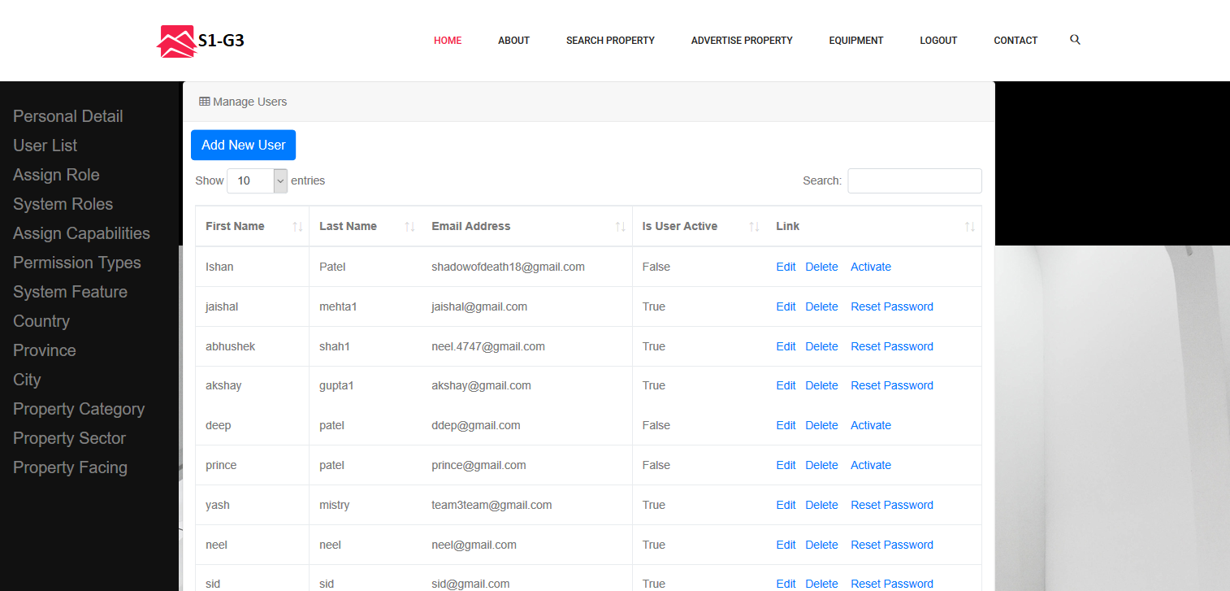

As you can see over here, We have list of all users. Here user named as Ishan’s account is not activated. The admin can activate it.

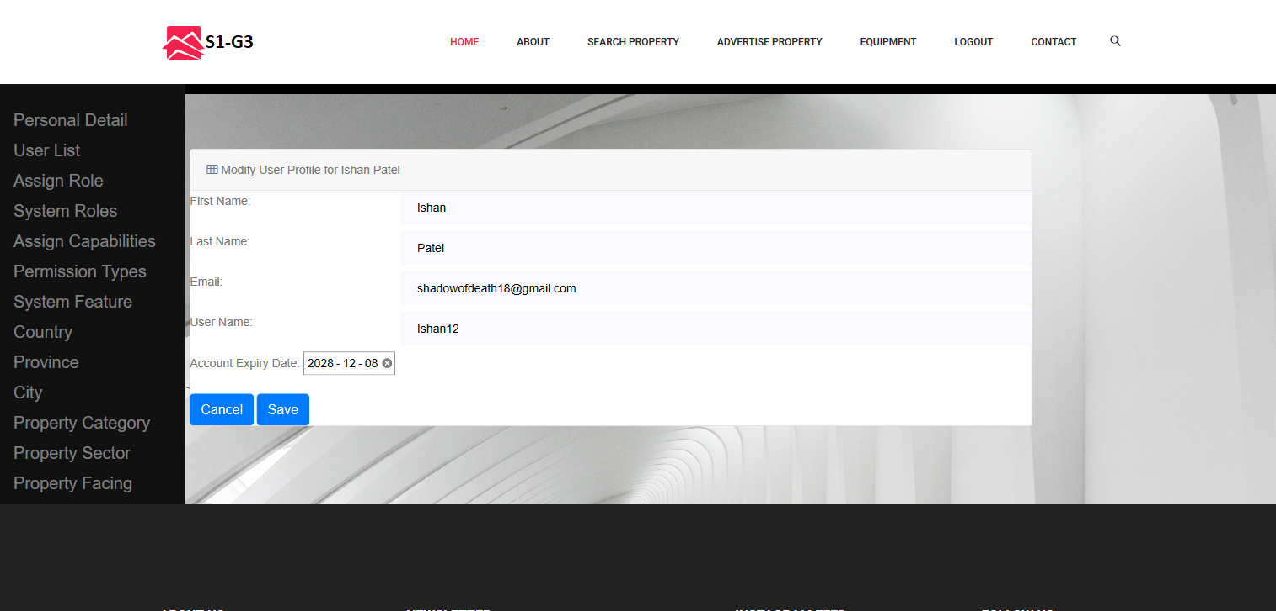

The admin can also change the user details as per requirement and can also set an expiration date on the account.

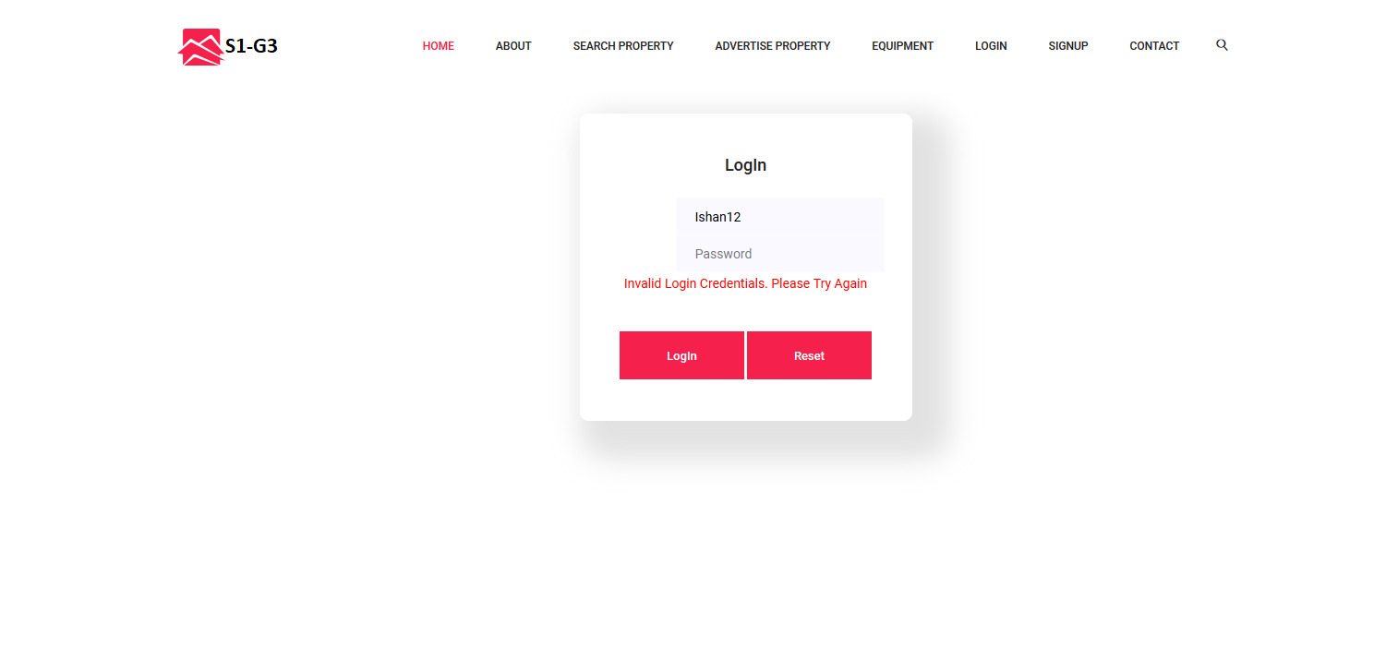

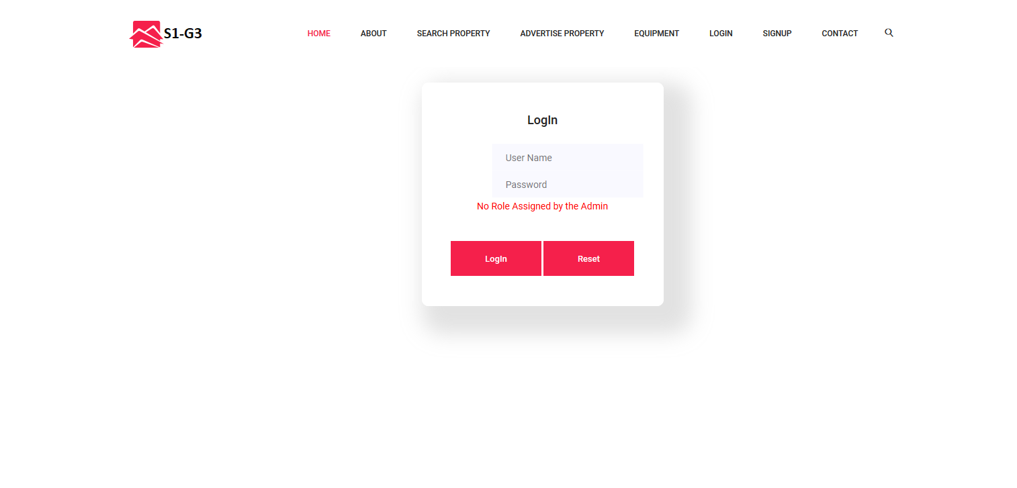

After the user account has been activated by the admin. The user can login to the account. On the first try the user would see something like this which state that the admin has to assign some role to the user named “Ishan12”.

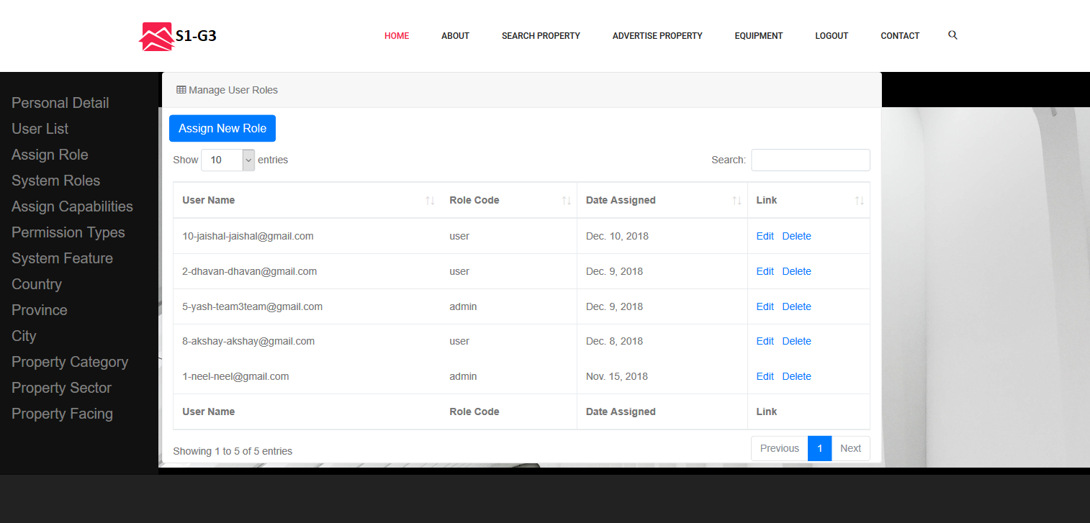

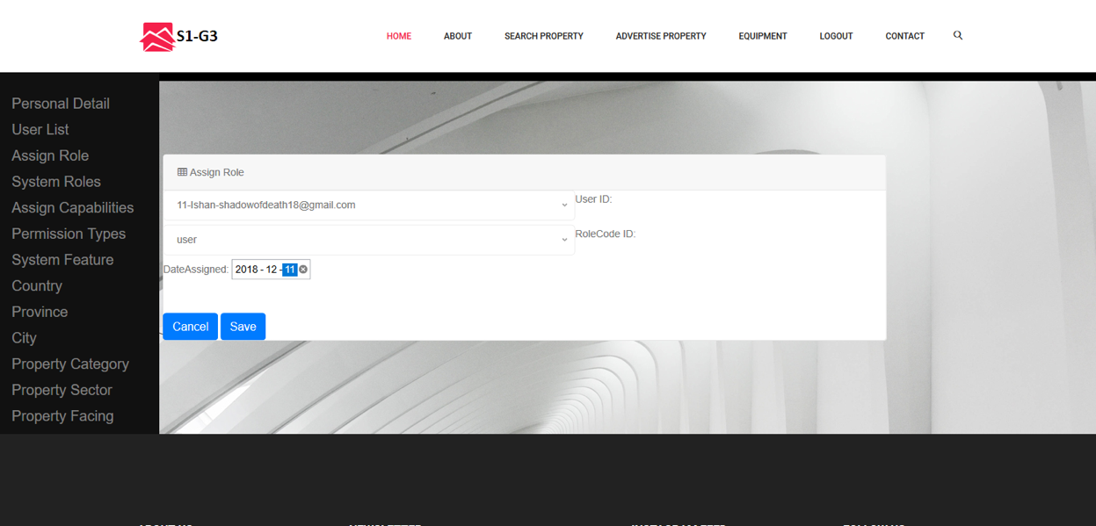

The admin logs in to their account and click on the assign Role tab and can see a page such as this. Here we have assigned “user” role to the user named “Ishan”

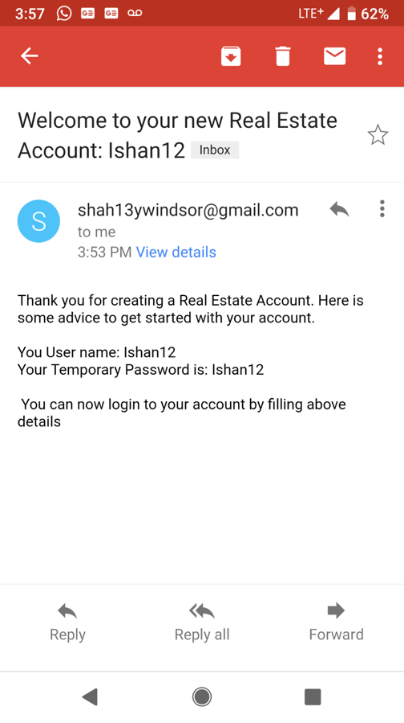

Email would be sent to the user with their username and password after the admin has activated their account.

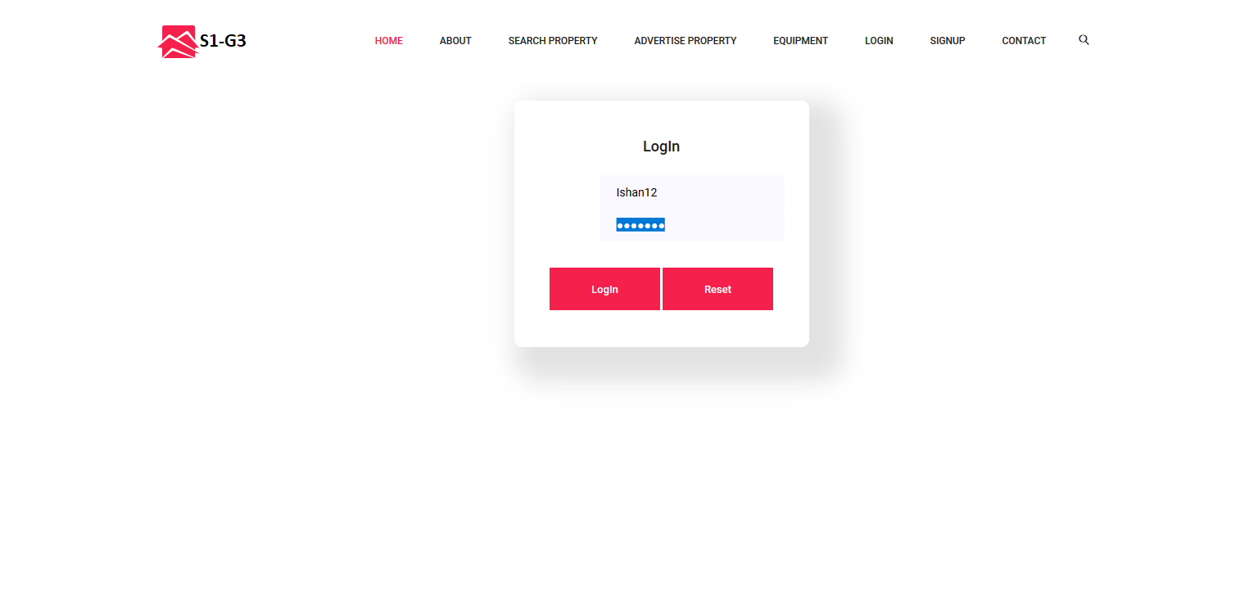

The user Logs in to his/her account

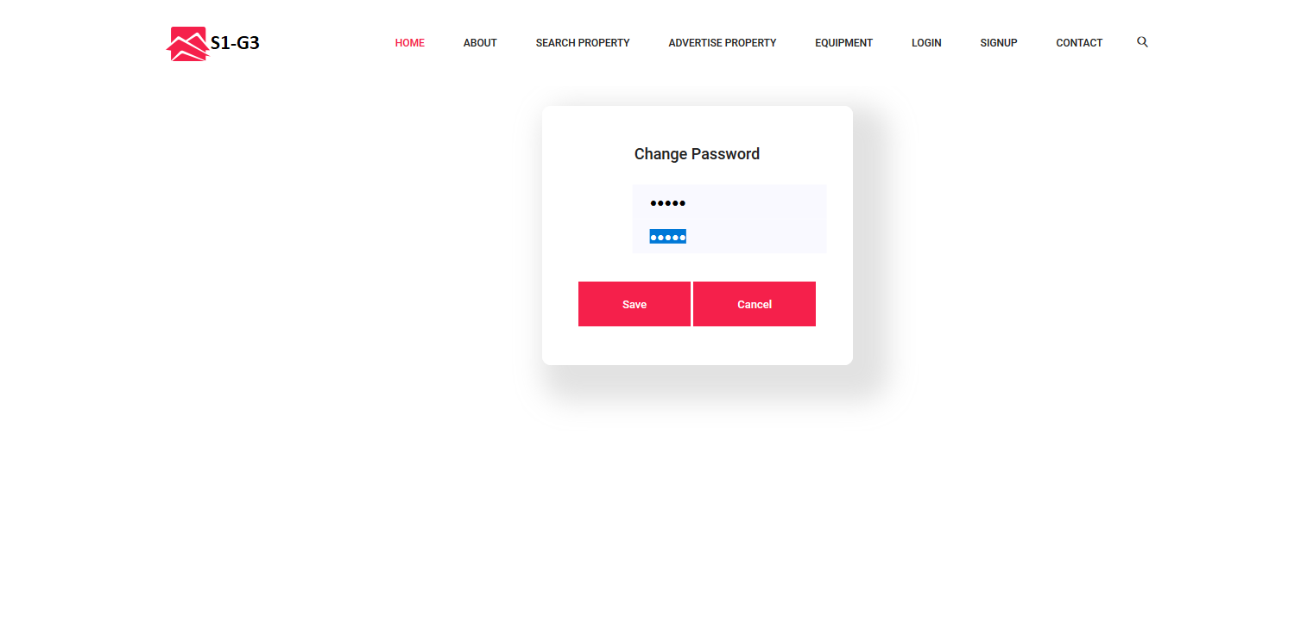

On the first Login the user would be required to change the password. Which was initially same as the username.

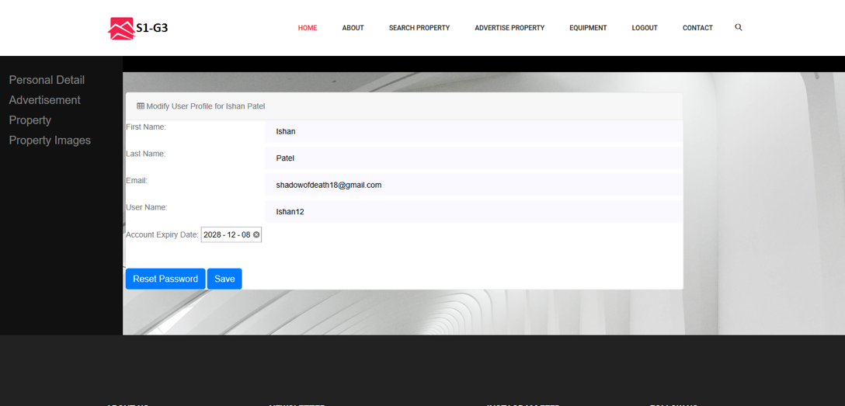

The user can view their personal details and modify accordingly.

**Web Page Content**

**USER:**

**Home Page :**

The home page shows a landing a page with an image and below it you can find list of all latest properties. Here you can click on More Info button to see details about the user’s property.

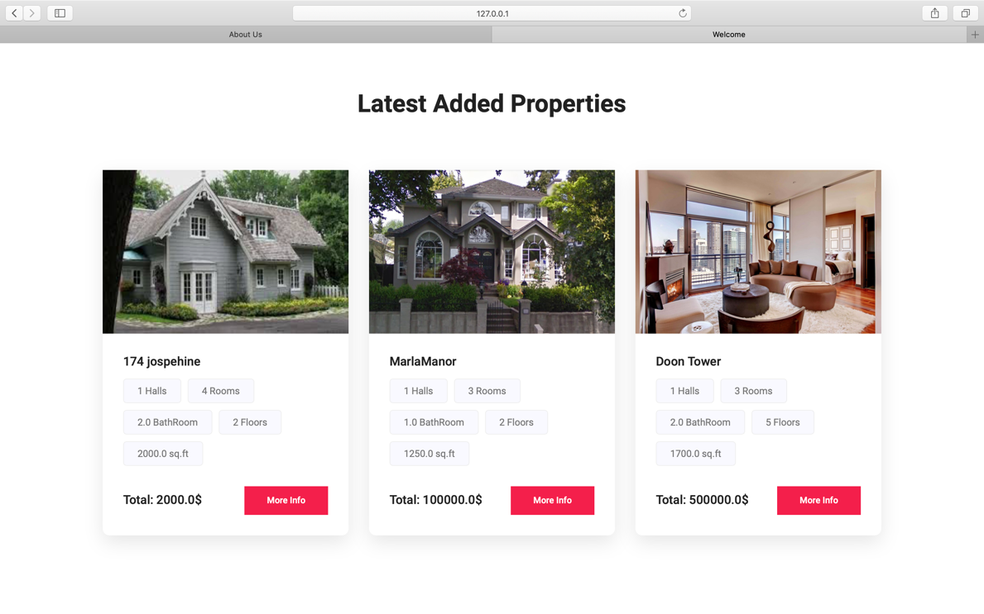

**About Us:**

This is page gives insights on the project information and team members along with some user comments and feedbacks.

**Search Property:**

This page provides filters on searching for various properties. On this page there are 5 basic filters namely Category, Sector, Country, Province and city respectively.

* **No filter applied :** The image below shows list of all properties in descending order when the search button is clicked without any filters

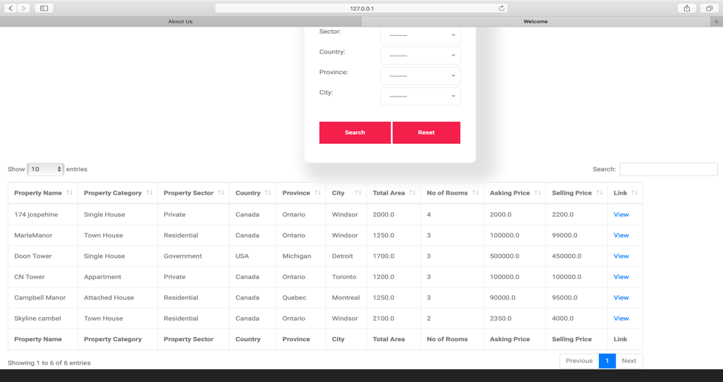

* **Filters Applied:**

When filters are applied then you will get the list of properties according to the filters applied as shown in figure below: Here filter on country is applied.

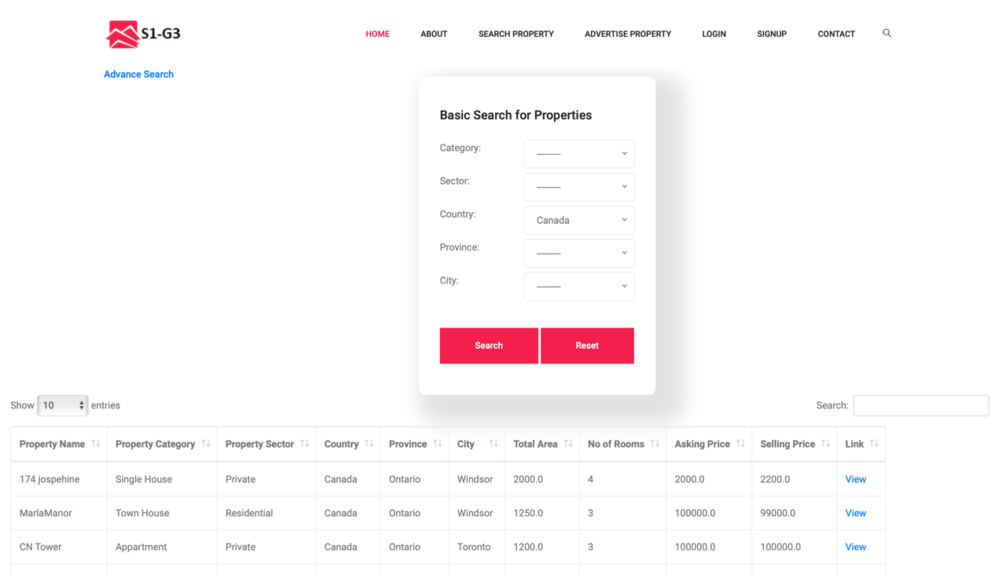

* **Search Property/ View a link:**

When you click a ‘view’ link in the list in search property Page then the user is redirected to a new page where they can see more information on that particular property as you can see in the figure below.

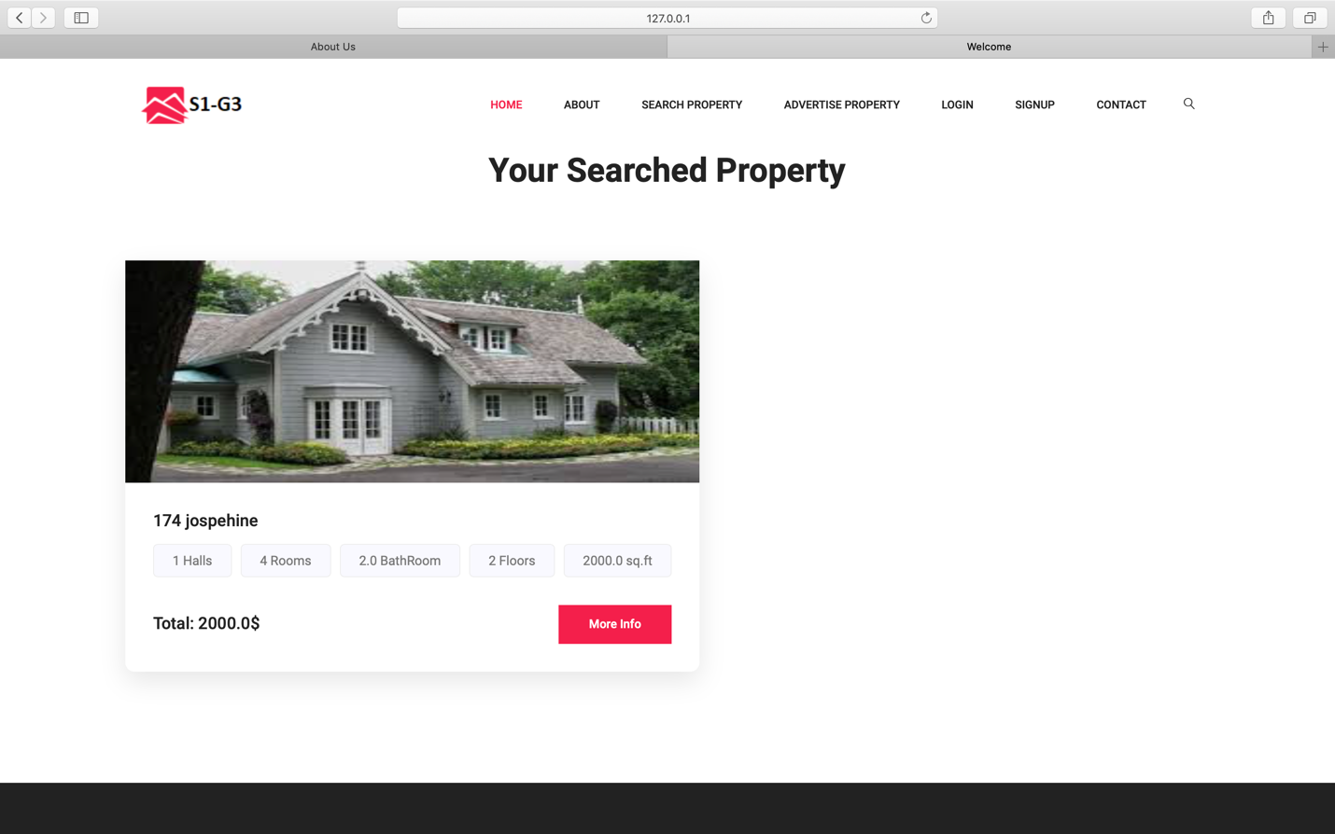

* **Search Property/ View a link/ More Infor:**

When you click on more info button you get a modal which displays more information of the selected property such as Images, Property Facing, Property Sector, Halls, Rooms etc. You can see the figure below:

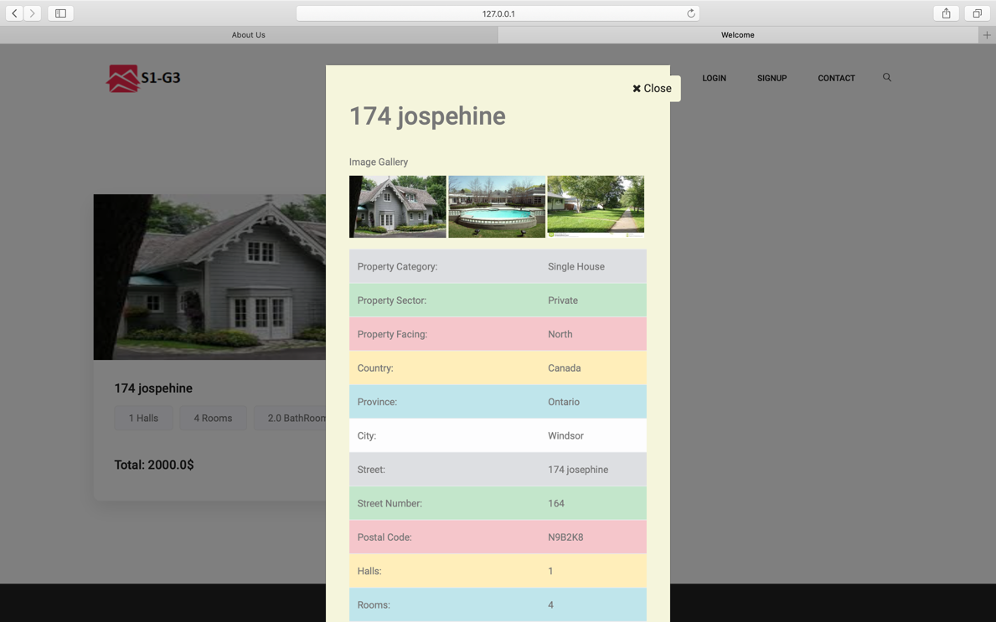

* **Search Property/ Advance Search:**

We have created a advance search page which has all the basic filters like Category, Sector etc but also few new filters such as Asking price range and Property Area. You can turn these filters on or off depending upon your requirement. Here as you can see in the image we have selected Price range between $200 to $3000 and total area between 200 sq.ft to 2000sq.f and we got 1 result which matches all the constraints provided.

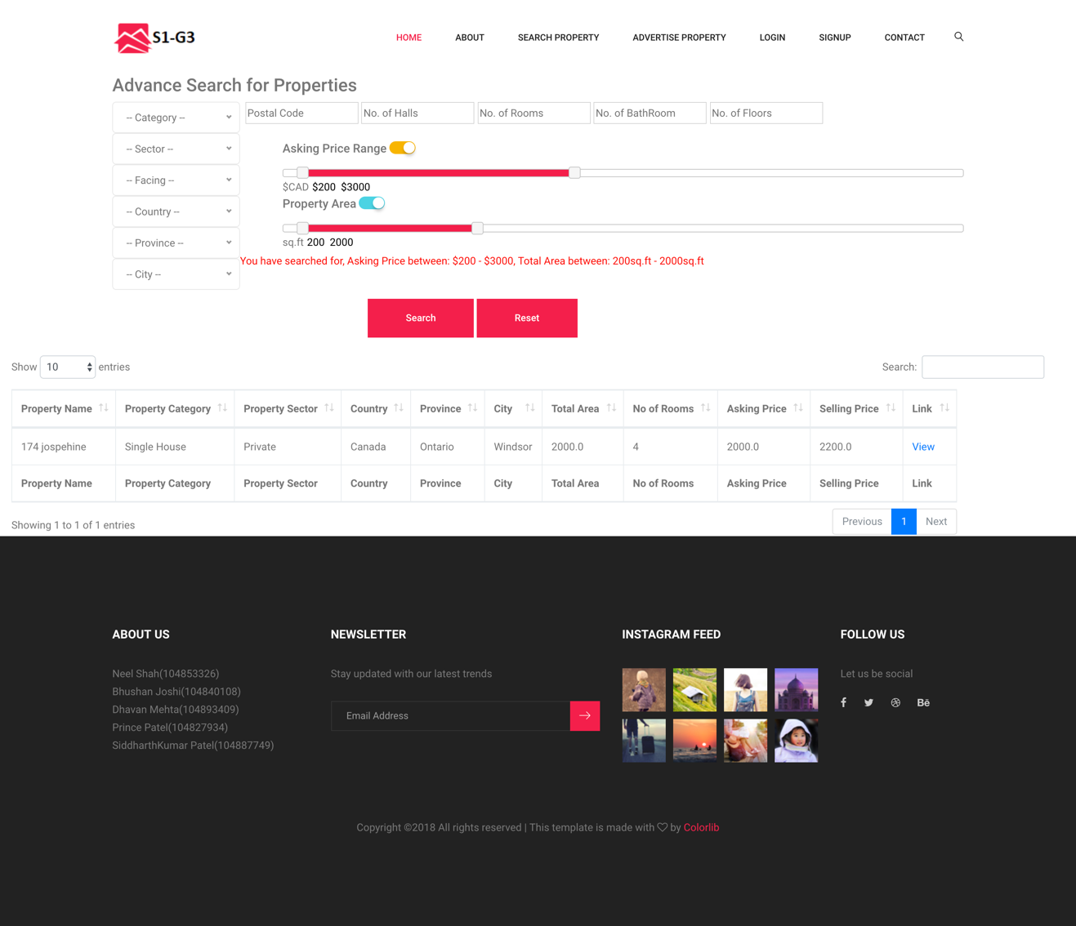

**Advertise Property:**

This page displays all the properties which user have advertise. Each property has a start date and end date.

If the start is more than the current date then that advertisement would be displayed on the date provided by the user.

If the end date has expired then that advertisement wont be displayed over here.

The user can select the more info button for more detailed information regarding the property.

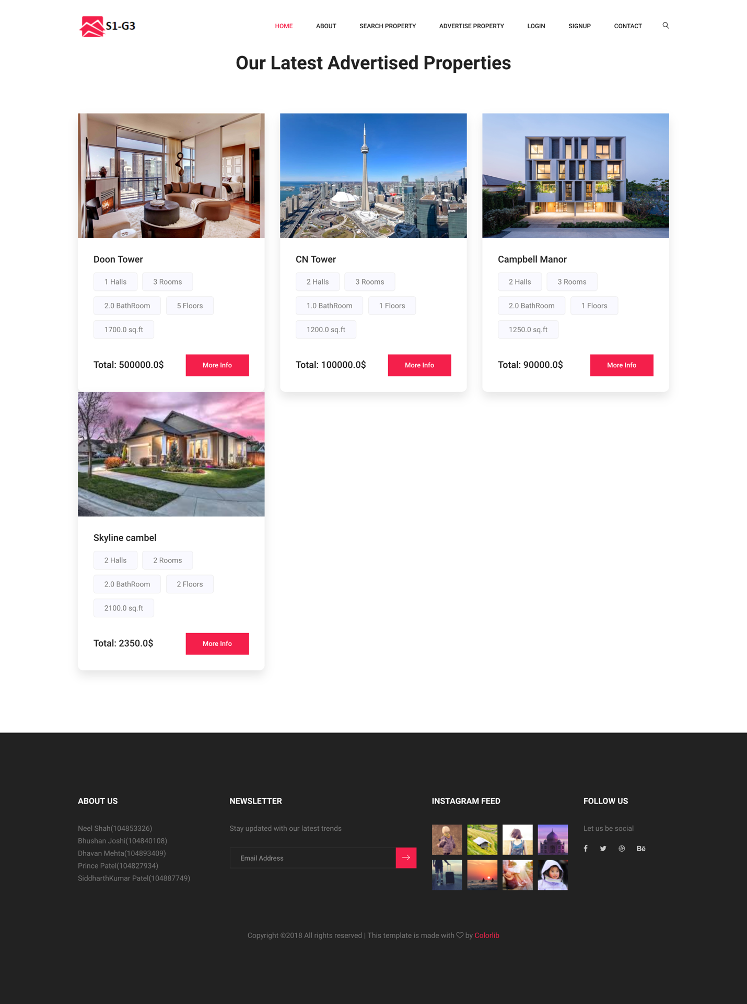

**Login:**

There’s one login page where user can log In to the system. (Explained before in functionalities section)

**Sign Up:**

Here the user can sign up for the services. They have to be authenticated by the admin.(Explained before in functionalities section)

**Contact Us:**

This is the contact us page where user or any person in need of assistance and contact us.

**ADMIN**

***“ALL PAGES HAVE ADD UPDATE AND DELETE FUNCTIONALITIES”***

**Personal Detail:**

Here the admin can see his/her personal details such as Firstname, Lastname, Account Expiry Date etc and can also edit and save the changes to the database.

**User List:**

Here the admin can see list of all users enrolled into the system. On this page the admin can activate the users and can also reset their passwords when required.

**Assign Role:**

Here the admin can assign various roles to the users. The role includes ‘user’, ‘admin’ and ‘operator’

**System Role:**

Here, the admin can create different system role.

**Assign Capabilities:**

The admin can assign different types of capabilities to the user such as adding new user account, add a system role, add properties, edit properties, view personal information etc.

**Permission Type:**

Here different database permissions are given to the user such as insert, update, Delete etc.

**Country**:

Here the admin can add update or delete different countries which are supported by the business.

**Province**:

The admin can add supported province with respect to the country.

**City**:

The admin can add supported Citites with respect to the Province.

**Property Category**:

Here the admin can add update or delete category such as a building, mall, Factory etc.

**Property Sector**:

Here the admin can add a sector to a property. This sector can be a Rural, government, commercial or any other sector provided a meaningful name.

**Property Facing**:

Property Facing page can add different sides/direction which are provided/ supported by the business such as North facing, south facing etc.

**Advertisement**:

Here the admin can create,update or delete an advertisement for a particular property. Like all other pages this page is also interlinked with other pages so that you can select a particular property and other details from the drop down menu.

**Property**:

This page provides CRUD operation like every other admin page. The CRUD operation is performed here on different properties.